What will we be learning?  Work  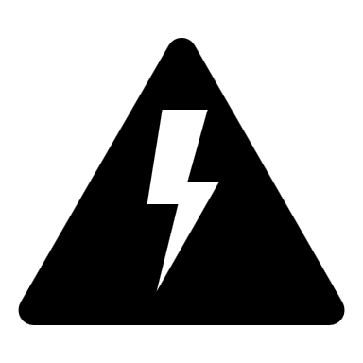 | Why this? Why now?  Previous Learning  Forces, Energy  Future Learning  Wave Properties, Heating & Cooling,  Enquiry Processes  Identify Variables, Collect Data, Present Data, Analyse Patterns, Draw Conclusions, Justify opinions and conclusions. | Key Words:  Work  Simple Machines  Lever  Gear  Pivot  Effort
What will we learn?
- How to label a lever with load, pivot and effort.
- How to use the equation Work Done = Force x distance
- How to carry out an experiment to show the relationship between distance from a pivot and force produced.
- How to link the idea of the human arm as a lever and explain tendon attachment and force produced.
- How to extrapolate a graph.
Misconceptions in this topic
- Some people think that energy can be lost or used up, energy is always conserved but may be transferred to a different energy store.

What opportunities are there for wider study?
Careers - Engineer, Architect, Construction, Civil Engineering, Aviation, Automotive Engineer, Car mechanic, Production Engineer.
STE(A)M – For details of courses and opportunities look at:
https://highcliffe.sharepoint.com/sites/LearnSTEM
How will I be assessed?
End of Topic Assessment

